HIMSS 2005 Design Specification

Version | Date | Author | Comments
0.1 | 1/29/2005 | SWD | Initial Draft

Introduction
This document describes the design of the software used in the HIMSS Interoperability Showcase Demonstration.

Eventually this document should include
- some sequence diagrams to make data flow clearer
- the format of the documents returned from the registry

XDS Implementation
In the HIMSS interoperability showcase we are both an XDS Document Source and XDS Document Consumer [see XDS spec].

XDS Message Flow
All messages to the XDS registry (queries) and XDS repositories (document submissions) have an identical data flow.

Each transaction is currently implemented as a stateless transaction. A HTTP POST or GET is generated by a web browser to a servlet; the servlet extracts parameters from the HTTP request and generates a ebXML SOAP message; the reply returns as a org.jdom.Document object containing the XML result from the registry or repository. This is then transformed by a stylesheet for display.

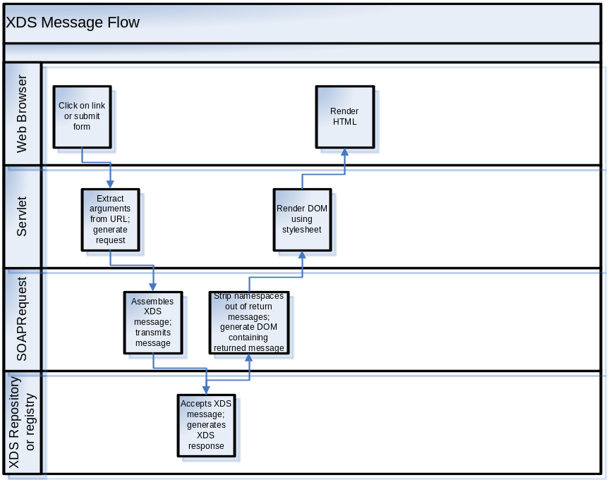
Yes – I know I need to get a better version of Visio to make a more appropriate document.

Browser
Both FireFox and IE are supported. No special software has been installed on either; only standard HTTP and HTML are used.

Servlet
Servlets were used instead of the Struts framework because of Sean’s inexperience with Struts. It may make sense before HIMSS to build a Struts framework if that makes construction of the UI more robust. If so – the servlet layer is quite thin and the Struts replacement would also be a minimal amount of code.

The servlet layer generates a call to the SOAPRequest layer. In return a org.jdom.Document object is returned. If the servlet layer is replaced with a Struts layer I hope that nothing will change in lower layers – that Stuts simply gets the same Document objects.

SOAPRequest
This is the layer that
- takes the objects created by the servlet layer
- generates the appropriate ebXML message
- embeds the message in a SOAP envelope
- sends the message to the XDS registry or repository
- receives the XDS reply and turns it into a org.jdom.Document object.

This is probably the worst-structured layer in the system.
- JAXB for outgoing messages with validation turned off.
- Namespace stripping.
- Writing intermediate results to a file.
- Mixture of switch statements and oo programming. The switch statements were useful when the first pre-connectathon unit tests were run; this all needs to be refactored.

[Need to describe some of the problems with namepaces with NIST software]

XDS Registry or Repository
The registry or repository communicate with the SOAPRequest layer solely through the XDS protocol. At the HIMSS demonstration the registry has been implemented by NIST (National Institute of Science and Technology) and the repository has been implemented by Intersystems, Dictaphone, or Eclipsys.

XML document rendering
TransformXSLT servlet.
Specifies a URL of the source document and the name of a stylesheet located in the tomcat/data/stylesheets directory to generate HTML output.

Currently available stylesheets include
Ccr2htm.xsl | Transforms CCR xml to HTML
Cda2htm.xsl | Transforms CDA document to HTML
Identity.xsl | Returns the input document unchanged (except for namespace removal)
FolderNodes.xsl | Renders XDS folders and their contents in a moderately ugly fashion.

[A few more too]

CCR Editor
TBD.

CCR also needs to have link to WADO study containing cardiac MR.

CDA Editor
TBD.

Need to make the boilerplate CDA using the report text generated by Dr. Channin.
The editor only substitutes name, patient id, and time in the boilerplate CDA. This substitution will happen automagically.

Folder-based UI
TBD.

Basic Demo workflow
[Note: the following assumes that we are storing CCRs in XDS and not in our own repositories for HIMSS.]
- Select Patient. A ‘patient’ arrives at our booth and gives us their patient id (which is on their badge number). We enter the patient id in an form in a web browser.
- Display of patient folders – one per CCR? Or just the latest?
  - XDS query for documents belonging to a patient. A query is made to the NIST registry; the results are a list of documents.
    - If there are no documents this means that either the patient id is incorrect or that the patient has no documents in the system yet. If it is the former we can’t help them – we have no way in the showcase to make a new patient. If it is the latter then we need to send them to Siemens so that they get a proper referral to us. Since we need a CCR on the system to bootstrap our own CCR we can’t be the first booth on their list.
  - The CCR objects are displayed.
- Display documents for the patient. Siemens will have entered a CCR for the referral to the MedCommons Cardiologist and a discharge summary in PDF form.
Rendering is done in two distinct ways: for PDF documents the link is shown in a specified place (page, frame, or div tag); for CDA and CCR documents a XSL transform is done in the TransformXSLT servlet.
The MedCommons Cardiologist should
  - discuss these documents with the patient. This demonstrates that documents can be shared between different vendor’s systems.
  - show them their cardiac MR study in WADO.
  - Generate a new CCR using the latest CCR as input. Insert the link to their cardiac MR study into a CCR. See the CCR editor section above.
  - create a new CDA document with the patient’s demographics. See the CDA editor section above.
  - Upload these documents to the Intersystems repository.
  - Show the documents to the patient.
  - Send them on his way to the next booth

This section needs work.

Appendix: Current list of issues
- Refactoring of the SOAPRequest layer. This will be done after HIMSS. Some further details in Mantis #302, #304, #305, #306.
- Race condition in XDS message mechanism (Mantis #309). This will be fixed before the show.

This layer is implemented in the class SOAPRequestDOM. The name also needs to be made more informative.
It is unclear what to do if we are given the patient id of a person other than the person in the booth. Do we tell them that our security model prevents us from helping them?
CCRs are extrinsic objects in the XDS world. The following query returns the list of all extrinsic objects for patient MEC-801: http://mcpurple06.homeip.net:9080/router/XdsQueryDocumentsForPatient?patientId=MEC-801 Either we need to add URL arguments to limit the document types to CCRs or just use XSL to select these from the returned XML.
For example: http://mcpurple06.homeip.net:9080/router/TransformXSLT?sourceURL=http://hcxw2k1.nist.gov:8080/xdsRep/f670efdf-e281-453d-b315-e3009385ffd1.xml&stylesheet=ccr2htm.xsl Will use the ccr2html.xsl stylesheet to transform the XML document located on the hcw2ki.nist.gov server.
Perhaps the CCR with the embedded link should be made first and then it is shown to the patient? If so – then the order of steps b and c are reversed.

